Curriculum Vitae  Immanuel Scholz  Date of Birth: 16.10.1978  Place of Birth: Dresden  Address: Unterhachinger Str. 77e, 81737 Munich  Phone: +49 172 9891416  Email: immanuel.scholz@gmail.com  Web: imi.eigenheimstrasse.de |  |  |  |  | 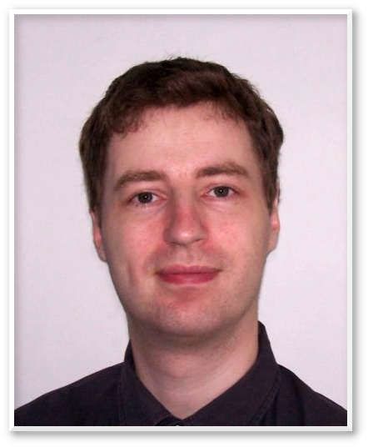
 |  |  | C++ | ★★★★★
 |  |  | C# | ★★★★★
 |  |  | Java | ★★★☆☆
 |  |  | Python | ★★★☆☆
 |  |  | Ruby | ★★☆☆☆
EMPLOYMENTS
01/2020 – today | Realmforge Studios GmbH (Technical Lead / Lead Programmer)  Game development of full-price games in C++, GIT, Unreal Engine, Windows / Linux / Mac / X-Box / Playstation
09/2019 – 12/2019 | Trivium eSolutions GmbH (Senior Software Developer)  C++ development, precision measurement devices in construction and building survey. STL, boost, CMake, GIT, Perforce
05/2018 – 08/2019 | BMW Group (Software Developer Specialist)  C++ development and integration UDS – system functions in Adaptive AUTOSAR, SomeIP, Embedded Linux, GIT, Python, Bash, Bazel, Docker, CMake…
04/2010 – 04/2018 | Realmforge Studios GmbH (Senior Software Developer)  Game development of 4 full-price games in C++, C#, GIT, Unity3D, STL, Lua, Windows / Linux / Mac / X-Box / PS4
12/2009 – 04/2010 | SQL AG (Software Developer)  Java – Development of B2B and Customer Platforms. Java ServerFaces, EJB3.0, JBoss, JavaScript, XML
05/2007 – 10/2009 | TU-Dresden (Research Assistant)  Java – Development, Research into anonymous communication protocols, international research project PRIME, PrimeLife
09/2000 – 04/2007 | Saxonia Systems AG (Senior Software Developer and Consultant)  Developer („firefighter“) in approx. 12 projects. Java, C++, Python, Ruby, PHP, Linux, Windows, SQL, XML, GIT, Subversion.. From 2000 Student Trainee, from 2004 Consultant, from 2006 Senior Dev. and Consultant
10/1998 – 10/2002 | TU-Dresden (Student Assistant)  Java Developer in Computer Security, Unix / Linux administrator for char „Operating Systems“. Java, Swing, Linux, AIX, RS/6000
EDUCATION
2009 |  | Collegue Lecturer in „Network Security“ at the BINUS University of Jakarta
2004 |  | Diplom-Informatiker (Master of Science) at the TU Dresden
1997 |  | Graduated from Vitzthum Gymnasium in Dresden
AWARDS AND MEMBERSHIPS
2006 – 2007 |  | Secretary of OpenStreetMap Foundation
2005 – 2007 |  | Member of „Board of Technology- and Architecture“, Saxonia Systems AG
2004 |  | Master thesis „Verschlüsselte SMS auf Basis des vorgeschlagenen Standards SEMS“ (encrypted SMS based on the proposed standard SEMS) was awarded „Best master thesis in 2004“. Benefactor: „Sächsisches Telekommunikationszentrum e. V.“ (Saxon center for communication, registered association)
OTHER
Sprachen |  | german – native language  english – fluent in spoken and written
Führerschein |  | International Driver License. German license Class B

